Session 7: Shared Learning

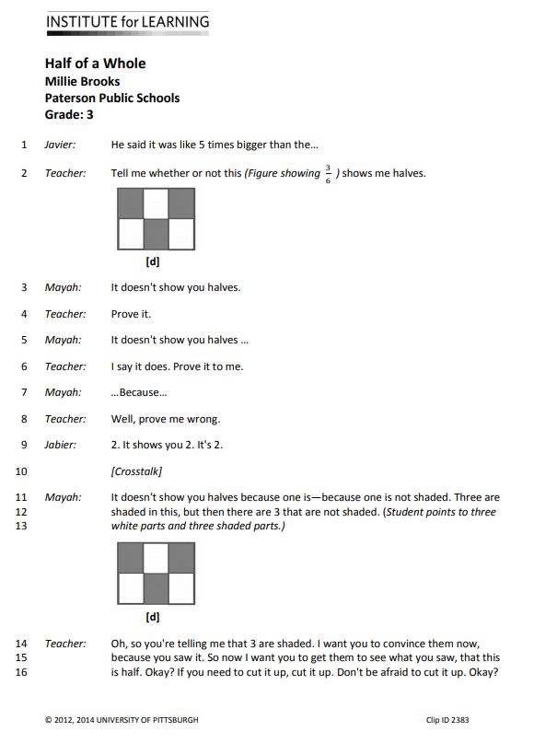

**This is an image of an activity from 
https://www.nctm.org/Conferences-and-Professional-Development/Principles-to-Actions-Toolkit/Resources/8-ES-Brooks-LessonGuide-HalfofaWhole/**

